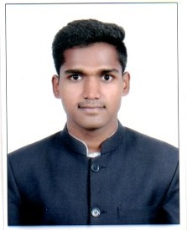
CURRICULUM VITAE

Name : Bolubanda Venkatesh
Phone No : 8686018004
E-Mail ID : bolbandav8@gmail.com

OBJECTIVES:
My Goals is to become the point person for position with in company utilizing and building upon my skills sourcing whole sale retail and operating by continuously contributing to the company. And seeking out professional development.

EDUCATIONAL
Course | Board / University | Institution | Year of pass
BHMCT | Osmania University | Shri Shakti College of Hotel Management | 2019
Intermediate | Board of Intermediate,TS | New Era Jr. College | 2016
SSC | Board Secondary Education,T S. | Z P High School | 2014

TECHNICAL SKILLS
Working knowledge on MS-office

INTER PERSONAL SKILLS
- Team Work.
- Hard Work
- Punctuality

INDUSTRIAL EXPOSE
I have undergone 4 months of training in all 4 major departments in park hyatt goa resort and spa from 1st December to march 31st 2018.

ACHIEVEMENTS:
- Achieved Medal Second Price in cricket at college level.
- Achieved District First price is essay writing at School level.

PERSONAL DETAILS
Father’s Name ; B Anjaneyulu
Date of Birth : 16.05.1998
Languages known : Telugu, Hindi, English
Address : Prakash nagar, Begumpet
Hyderabad, Telangana .

DECLARATION
I I hereby declare that all the details furnished here are true to the best of my knowledge

Date:

Place:
(B VENKATESH)

